Test Case: tc006_SPX_Dev5_Crear_Requisicion_Spot_Tipo_Cobro_Proyect_Urgent
Step 1 - Enter username and password and click to button Enter: Credentials Entered
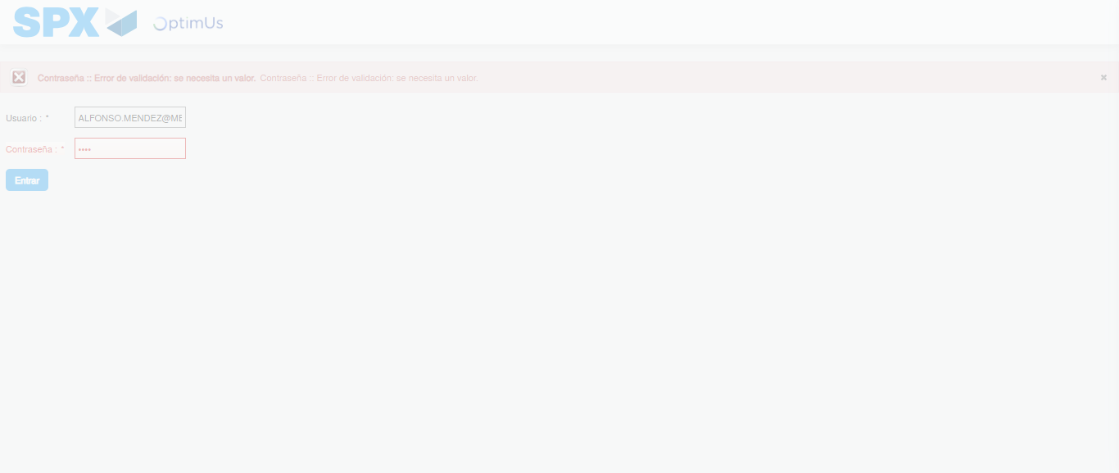Image file-name: QC_Testing-tc006_SPX_Dev5_Crear_Requisicion_Spot_Tipo_Cobro_Proyect_Urgent-1783379226187

Step 2 - Select to UEN and Access to Spot Buy Requisitions : UEN Correctly selected and Correct access
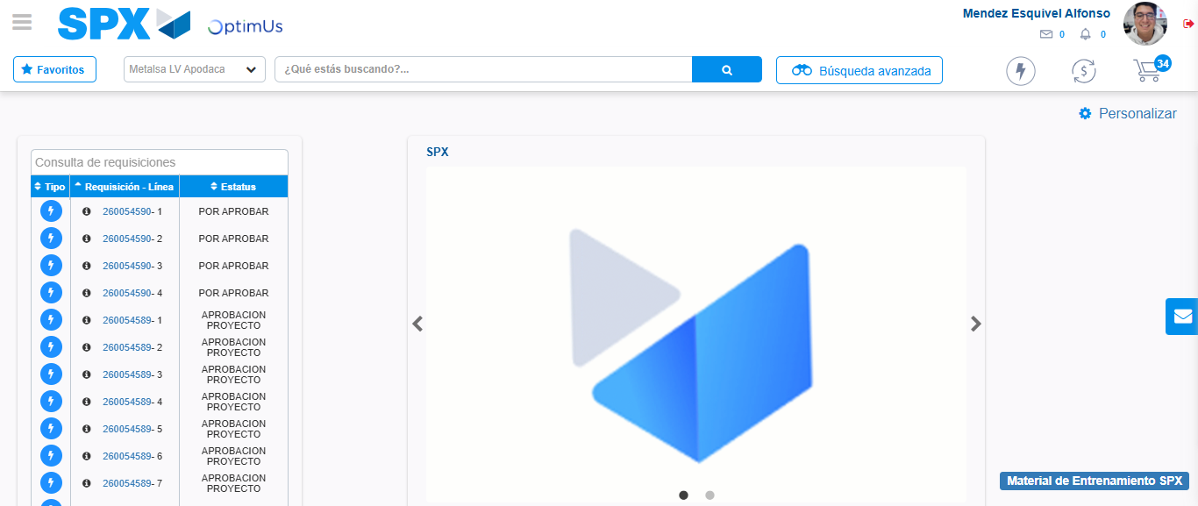Image file-name: QC_Testing-tc006_SPX_Dev5_Crear_Requisicion_Spot_Tipo_Cobro_Proyect_Urgent-1783379251896

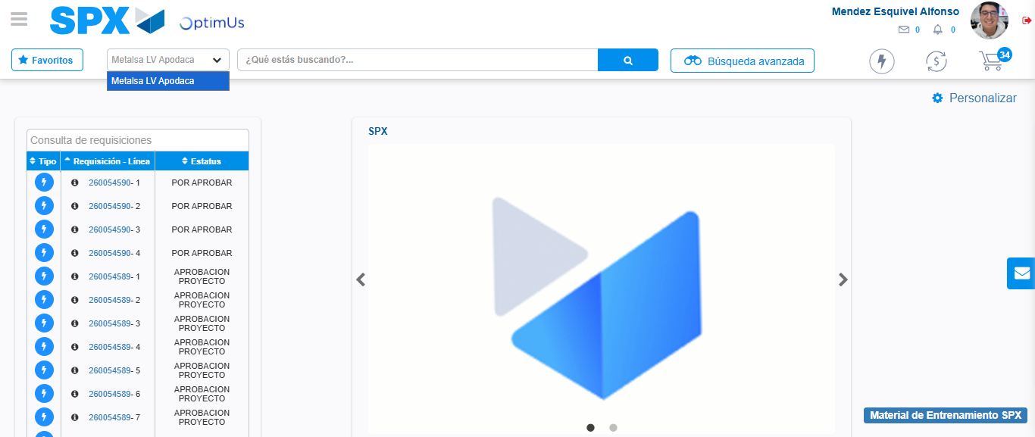Image file-name: QC_Testing-tc006_SPX_Dev5_Crear_Requisicion_Spot_Tipo_Cobro_Proyect_Urgent-1783379254432

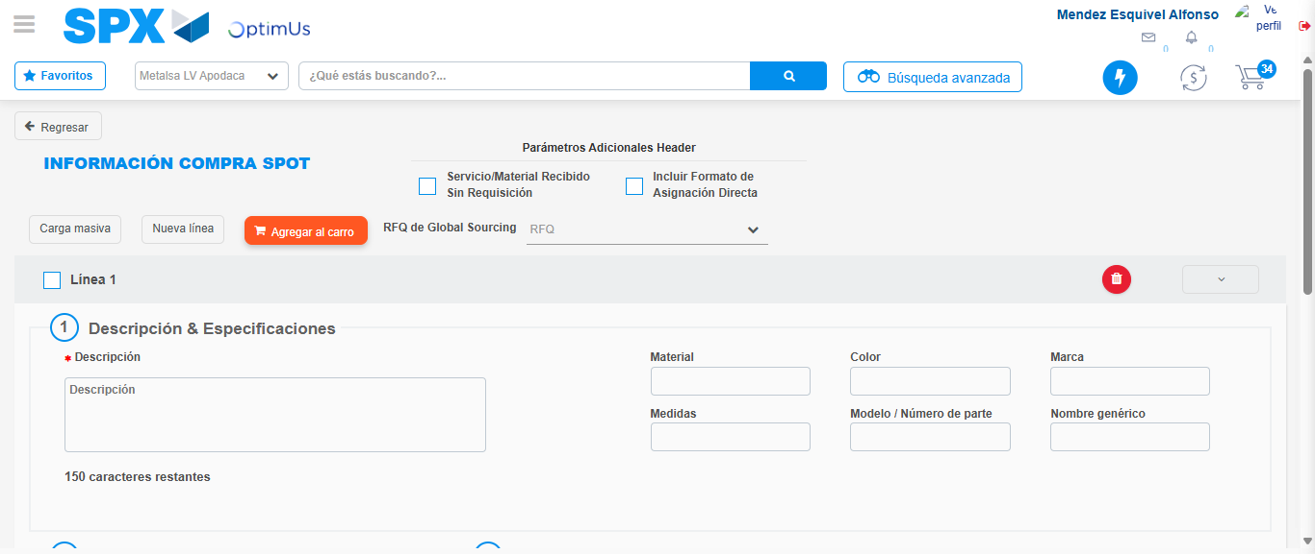Image file-name: QC_Testing-tc006_SPX_Dev5_Crear_Requisicion_Spot_Tipo_Cobro_Proyect_Urgent-1783379278884

Step 3 - Data Capture Spot Buy Requisition: Data captured correctly
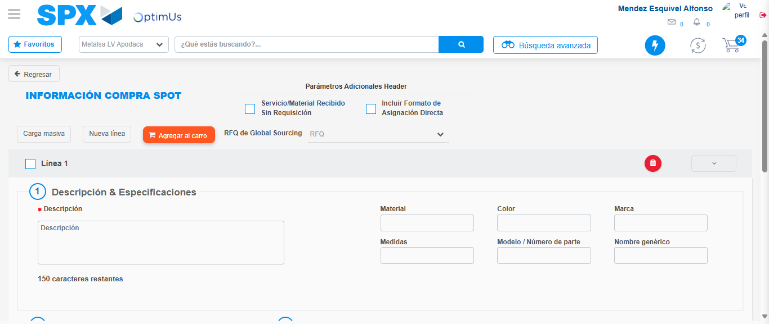Image file-name: QC_Testing-tc006_SPX_Dev5_Crear_Requisicion_Spot_Tipo_Cobro_Proyect_Urgent-1783379279142

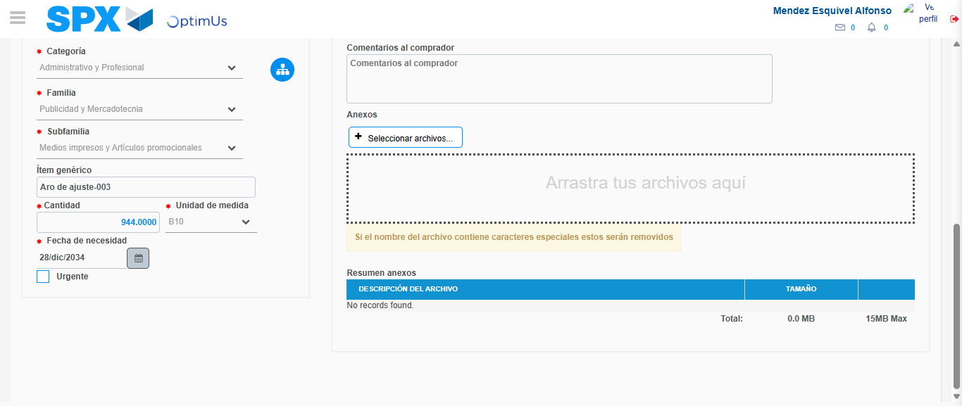Image file-name: QC_Testing-tc006_SPX_Dev5_Crear_Requisicion_Spot_Tipo_Cobro_Proyect_Urgent-1783379289144

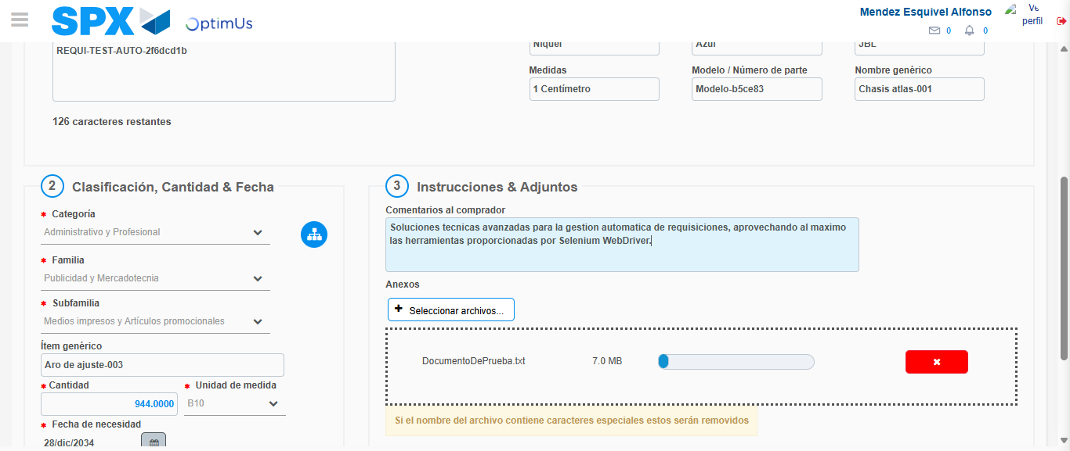Image file-name: QC_Testing-tc006_SPX_Dev5_Crear_Requisicion_Spot_Tipo_Cobro_Proyect_Urgent-1783379289906

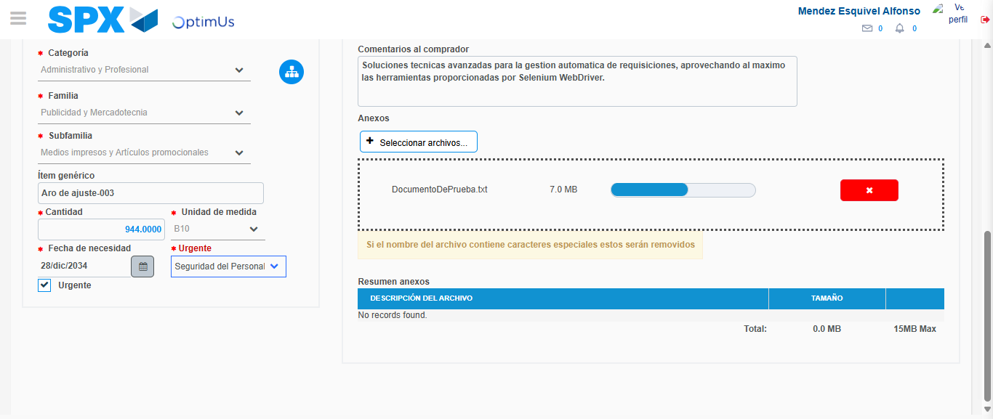Image file-name: QC_Testing-tc006_SPX_Dev5_Crear_Requisicion_Spot_Tipo_Cobro_Proyect_Urgent-1783379292988

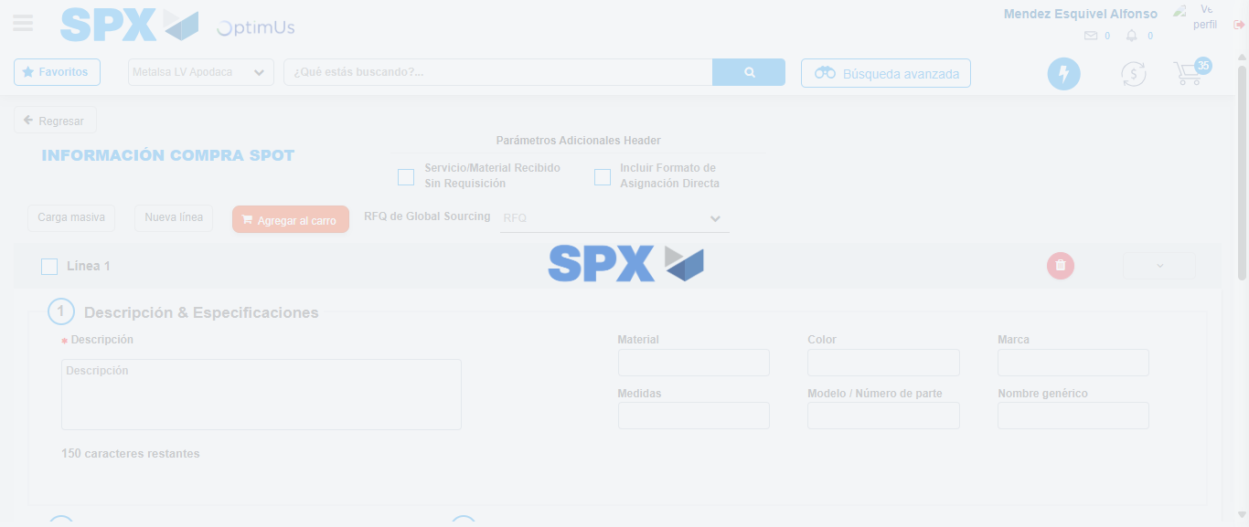Image file-name: QC_Testing-tc006_SPX_Dev5_Crear_Requisicion_Spot_Tipo_Cobro_Proyect_Urgent-1783379300900

Step 7 - Return to Main Page SPX : Return to Main Page SPX
Image file-name: QC_Testing-tc006_SPX_Dev5_Crear_Requisicion_Spot_Tipo_Cobro_Proyect_Urgent-1783379251896

Image file-name: QC_Testing-tc006_SPX_Dev5_Crear_Requisicion_Spot_Tipo_Cobro_Proyect_Urgent-1783379254432

Image file-name: QC_Testing-tc006_SPX_Dev5_Crear_Requisicion_Spot_Tipo_Cobro_Proyect_Urgent-1783379278884

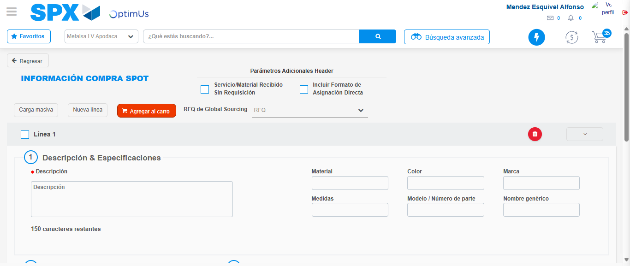Image file-name: QC_Testing-tc006_SPX_Dev5_Crear_Requisicion_Spot_Tipo_Cobro_Proyect_Urgent-1783379303230

Image file-name: QC_Testing-tc006_SPX_Dev5_Crear_Requisicion_Spot_Tipo_Cobro_Proyect_Urgent-1783379303401

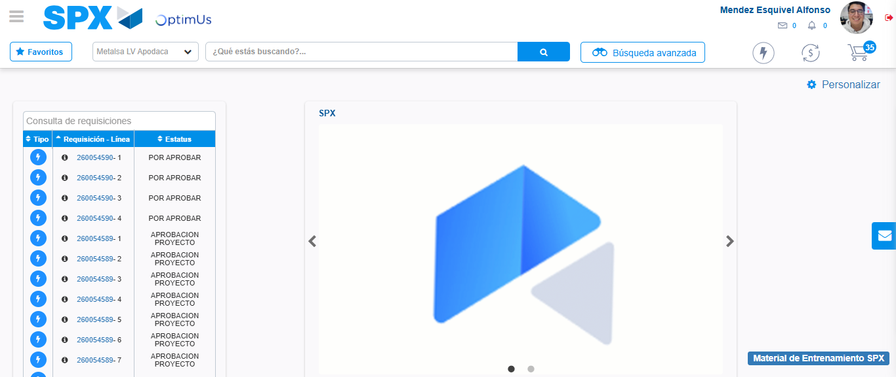Image file-name: QC_Testing-tc006_SPX_Dev5_Crear_Requisicion_Spot_Tipo_Cobro_Proyect_Urgent-1783379324428

Step 8 - Log Out : Log Out SPX
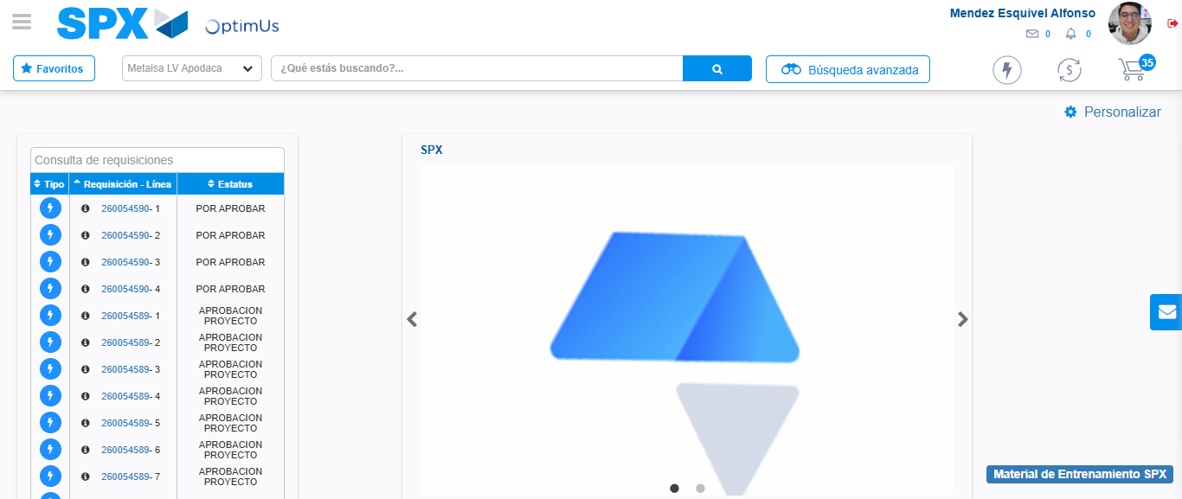Image file-name: QC_Testing-tc006_SPX_Dev5_Crear_Requisicion_Spot_Tipo_Cobro_Proyect_Urgent-1783379324632

